BUSINESS REQUIREMENTS DOCUMENT (BRD)
EMI Calculator Application for Loan Management
Fidelity National Financial - Finance Domain
Table of Contents
1. INTRODUCTION
1.1. DOCUMENT PURPOSE
1.2. INTENDED AUDIENCE
1.3. PROJECT BACKGROUND
1.4. BUSINESS GOALS/OBJECTIVES TO BE ACHIEVED
1.5. STAKEHOLDERS
1.6. DEPENDENCIES ON EXISTING SYSTEMS
1.7. REFERENCES
1.8. ASSUMPTIONS 5
2. REQUIREMENTS SCOPE
2.1. IN SCOPE (FEATURES/MODULES/SCREENS/USE CASES)
2.2. OUT OF SCOPE (FEATURES/MODULES/SCREENS/USE CASES)
3. FUNCTIONAL REQUIREMENTS
3.1. ACTOR/USER PROFILE SPECIFICATION
3.2. USE CASE DIAGRAM/FEATURES LIST
3.3. USE CASE/FEATURE SPECIFICATION
3.4. BUSINESS RULES
4. DATA REQUIREMENTS
4.1. DATA VOLUMES
4.2. DATA CONVERSION
4.3. DATA RETENTION AND ARCHIVING
4.4. PRIVACY IMPLICATIONS
5. NON-FUNCTIONAL REQUIREMENTS
5.1. SECURITY REQUIREMENTS
5.1.1. Authentication
5.1.2. Authorization and Access Controls
5.2. AVAILABILITY REQUIREMENTS
5.3. USABILITY REQUIREMENTS
5.4. SYSTEM HELP REQUIREMENTS
5.5. PERFORMANCE REQUIREMENTS
5.6. SCALABILITY REQUIREMENTS
5.6.1. User Scalability
5.6.2. Application Scalability
6. INTERFACE REQUIREMENTS
6.1. USER INTERFACE REQUIREMENTS
6.2. SYSTEM INTERFACE REQUIREMENTS
7. BUSINESS GLOSSARY
APPROVAL
1. INTRODUCTION
1.1. DOCUMENT PURPOSE
This Business Requirements Document (BRD) defines the business needs and functional requirements for the Loan EMI Calculator Application at Fidelity National Financial (FNF). It serves as the primary reference for stakeholders to understand what the application must achieve and how it supports FNF's loan servicing operations.
The document establishes a clear agreement between business stakeholders and the technical team regarding the expected functionality, scope, and deliverables. It will be used to guide the design, development, and testing phases while ensuring all parties have a unified understanding of project objectives.
This BRD also serves as the baseline for formal stakeholder approval and It provides traceability between business goals and specific requirements, supporting informed decision-making throughout the project lifecycle.
1.2. INTENDED AUDIENCE
This document is intended for multiple stakeholder groups involved in the development and deployment of the EMI Calculator Application. Business stakeholders including senior management, product managers, and business owners need to understand the business objectives, scope, and expected benefits to make informed decisions and provide approval authority. Development teams comprising solution architects, software developers, and technical leads require detailed requirements to design and build the application components, including UI screens, backend logic, and integration points. Quality assurance managers and test engineers use this document as the basis for creating test cases, defining acceptance criteria, and validating that the application meets all specified requirements. Project managers and scrum masters track progress, manage scope, and handle change requests using this document as the baseline reference. Finally, loan officers and finance professionals at Fidelity National Financial who will use the EMI Calculator Application in their daily operations need to understand the application's functionality and capabilities.
1.3. PROJECT BACKGROUND
Fidelity National Financial (FNF) is a leading provider of title insurance, closing and escrow services, and other title-related services across the United States. As a FORTUNE 500® company and the highest-ranked organization in the title insurance industry, FNF serves residential and commercial property owners, lenders, builders, developers, attorneys, and real estate professionals with comprehensive financial protection and transaction services.
Currently, FNF's loan operations teams require an efficient and standardized tool to calculate loan EMI (Equated Monthly Installment) amounts for customers across different states and loan products. The existing process involves manual calculations or reliance on third-party tools that do not align with FNF's specific business rules, particularly regarding state-specific benefits and varying interest calculation methods.
This project aims to develop a dedicated Loan EMI Calculator Application that automates EMI calculations based on customer inputs such as loan amount, interest rate, tenure, and loan type. The application will incorporate FNF's business rules, including special provisions for customers in specific states like Karnataka and Goa, and support both fixed-rate and variable-rate loan calculations.
The initiative is part of FNF's broader digital transformation strategy to enhance operational efficiency, improve customer service delivery, and provide loan officers with reliable tools that reflect accurate calculation logic aligned with company policies and regulatory requirements.
1.4. BUSINESS GOALS/OBJECTIVES TO BE ACHIEVED
The Loan EMI Calculator Application project aims to achieve the following strategic business objectives:
Standardize EMI Calculation Process – Establish a unified and consistent approach to calculating loan EMI amounts across all FNF loan operations teams, eliminating discrepancies that arise from manual calculations or varied third-party tools.
Improve Operational Efficiency – Reduce the time spent by loan officers on manual EMI calculations by providing an automated, user-friendly application that delivers instant results, allowing staff to focus on higher-value customer service activities.
Ensure Calculation Accuracy – Minimize errors in EMI computations by embedding FNF's approved calculation logic directly into the system, including support for both fixed-rate and variable-rate interest methods and state-specific business rules.
Enhance Customer Experience – Enable faster response times to customer inquiries regarding loan repayment amounts, demonstrating professionalism and building trust through accurate and immediate information delivery.
Support State-Specific Business Rules – Implement regional discount policies (such as the one EMI discount for Karnataka and Goa customers) systematically, ensuring compliance with FNF's promotional programs and regulatory requirements.
Improve Data Integrity and Auditability – Capture customer loan details in a structured format that can be tracked, audited, and referenced for future loan servicing needs and compliance reporting.
Enable Scalability for Future Enhancements – Develop a foundation application that can be extended in future phases to support additional loan products, calculation methods, or integration with other FNF systems.
The successful delivery of these objectives will contribute to FNF's commitment to operational excellence and its reputation as an industry leader in providing reliable financial services to customers nationwide.
1.5. STAKEHOLDERS
The following stakeholders are involved in the Loan EMI Calculator Application project:
Project Sponsor – Senior Vice President, Loan Operations at FNF, responsible for project funding approval, overall strategic direction, and final sign-off on deliverables.
Business Owner – Director of Loan Services, accountable for defining business requirements, validating that the solution meets operational needs, and ensuring alignment with departmental objectives.
Product Owner – Loan Operations Manager, responsible for prioritizing features, providing clarifications on business rules, and serving as the primary liaison between the business and technical teams.
Business Analyst – Requirements gathering, documentation, stakeholder communication, and ensuring traceability between business needs and technical implementation.
Project Manager – Overall project coordination, timeline management, resource allocation, risk management, and status reporting to stakeholders.
IT Development Team – Application development, technical architecture design, coding, unit testing, and deployment activities.
Quality Assurance Team – Test planning, test case creation, functional testing, regression testing, and defect management to ensure quality standards are met.
End Users (Loan Officers) – Front-line staff who will use the application daily to calculate EMI amounts for customers and provide loan information during customer interactions.
Compliance and Legal Team – Review state-specific business rules and discount policies to ensure regulatory compliance and adherence to FNF's legal requirements.
IT Support and Maintenance Team – Post-implementation support, issue resolution, and ongoing maintenance of the application.
1.6. DEPENDENCIES ON EXISTING SYSTEMS
The Loan EMI Calculator Application is designed as a standalone solution with minimal dependencies on existing FNF systems. However, the following dependencies and integration considerations have been identified:
User Authentication and Authorization System – The application may need to integrate with FNF's existing identity and access management (IAM) system to authenticate users (loan officers and customers) and control access based on user roles and permissions.
Customer Database/CRM System – If customer information (name, location, contact details) needs to be pre-populated or synchronized, the application may require read-only access to FNF's customer relationship management (CRM) or customer master database.
State and City Master Data – The application depends on a master data repository containing current and accurate lists of states and cities to populate dropdown selections in the user interface.
Interest Rate Configuration System – The application may need access to FNF's rate management system or configuration database to retrieve current fixed and variable interest rates applicable to different loan products and regions.
Loan Product Catalog – Dependencies on FNF's loan product database to ensure the loan types available in the application align with currently offered products and their associated calculation rules.
Reporting and Analytics Platform – If usage tracking, calculation history, or business intelligence reporting is required, the application may need to integrate with FNF's existing reporting infrastructure or data warehouse.
1.7. REFERENCES
The following documents and resources have been referenced during the preparation of this Business Requirements Document:
FNF Loan Operations Policy Manual – Internal documentation governing loan processing procedures, calculation methodologies, and customer service standards applicable to loan products.
State-Specific Discount Policy Guidelines – FNF policy documents outlining promotional discounts and special benefits for customers in specific states (Karnataka and Goa).
EMI Calculation Standards – Industry-standard formulas and methodologies for calculating Equated Monthly Installments for both fixed-rate and variable-rate loan products.
Regulatory Compliance Documentation – Relevant federal and state regulations governing loan disclosures, interest rate calculations, and consumer financial protection requirements.
1.8. ASSUMPTIONS
The following assumptions have been made during the preparation of this Business Requirements Document:
User Access and Availability – It is assumed that all intended users (loan officers and customers) will have access to the necessary hardware, internet connectivity, and web browsers to access the Loan EMI Calculator Application.
Data Availability – Master data for states, cities, and loan types will be available and maintained by FNF's data management team, and this data will remain relatively stable throughout the project lifecycle.
Interest Rate Inputs – Users (loan officers or customers) will manually enter interest rates into the application. The system will not automatically fetch or validate interest rates against external rate tables in the initial release.
Single Currency Support – All loan amounts and calculations will be processed in a single currency (INR), and multi-currency support is not required for this phase.
Calculation Formula Approval – The EMI calculation formulas for both fixed-rate and variable-rate loans have been validated and approved by FNF's finance and compliance teams prior to development.
State-Specific Discount Policy – The one EMI discount for Karnataka and Goa customers is currently active and will remain in effect during and after the application deployment.
Browser Compatibility – The application will be developed to support modern, up-to-date web browsers (Chrome, Firefox, Edge, Safari) and will not require support for legacy or outdated browser versions.
Training and Change Management – Adequate training resources and change management support will be provided to end users to ensure smooth adoption of the new application.
Regulatory Compliance – All business rules and calculation methods defined in this document comply with applicable federal and state regulations governing loan products and customer disclosures.
Project Timeline and Resources – Sufficient project budget, resources, and timeline have been allocated to complete the development, testing, and deployment of the application as outlined in the project plan.

2. REQUIREMENTS SCOPE
2.1. IN SCOPE (FEATURES/MODULES/SCREENS/USE CASES)
The following features, functionalities, and capabilities are included within the scope of the Loan EMI Calculator Application:
User Interface Screen
The application will provide a single-screen web-based interface that serves as the primary interaction point for all users. This screen will include input fields for capturing essential loan information such as Customer Name, Loan Amount, Interest Rate, and Tenure. Users will be able to select the customer's location through State and City dropdown menus, where the City dropdown will dynamically populate based on the selected State. A Loan Type dropdown will allow users to choose between Fixed Rate and Variable Rate options. Additionally, a free-flow text box will be available for entering supplementary comments or notes. The interface will feature two primary action buttons: an OK/Submit button to trigger calculations and a Cancel button to reset the form. Upon successful calculation, a result popup or modal window will display the computed values in a clear and organized manner.
EMI Calculation Functionality
The application will perform comprehensive loan calculations based on user inputs. It will calculate the Equated Monthly Installment (EMI) amount that represents the monthly payment obligation for the customer. The system will compute the Total Interest amount that accumulates over the entire loan tenure, separate from the principal. It will also calculate the Total Amount Payable, which combines the original loan amount with the total interest charges. The calculation engine will support two distinct methods: Fixed Rate calculations that apply a constant interest rate throughout the loan period, and Variable Rate calculations that accommodate fluctuating interest rates based on the selected loan type. All calculations will be performed automatically upon user submission and will follow industry-standard financial formulas to ensure accuracy.
State-Specific Discount Logic
The application will implement special business rules for customers located in specific states. When a user selects Karnataka or Goa as the customer's state, the system will automatically identify this selection and apply a one EMI discount to the final calculation. This discount will reduce the Total Amount Payable by deducting one month's EMI from the overall repayment obligation. The discounted values will be reflected in the calculation results displayed to the user, ensuring that customers from these states receive the promotional benefit as per FNF's business policy. The discount logic will be seamlessly integrated into the calculation engine without requiring any additional user action.
Business Rules and Validations
The application will enforce several validation rules to ensure data integrity and proper user interaction. When users select "None" from either the City dropdown or the Loan Type dropdown, the free-flow text box will be automatically disabled, preventing any text entry until a valid selection is made. All mandatory fields including Customer Name, State, City, Loan Type, Loan Amount, Interest Rate, and Tenure must be completed before the calculation can be executed. The system will validate that numeric fields contain appropriate values and will prevent form submission if any required information is missing or invalid. Clear and user-friendly error messages will guide users to correct any data entry issues before proceeding with the calculation.
Calculation Output Display
Upon successful calculation, the application will present the results in a dedicated popup or modal window that overlays the main interface. This result display will clearly show three key values: the Monthly EMI Amount, the Total Interest payable over the loan tenure, and the Total Amount Payable including both principal and interest. All monetary values will be formatted appropriately with currency symbols and decimal precision for easy readability. The result popup will provide users with a complete summary of their loan repayment obligations, allowing them to make informed decisions. Users will be able to close the result popup and return to the main screen to perform additional calculations if needed.

IN SCOPE (Screens)

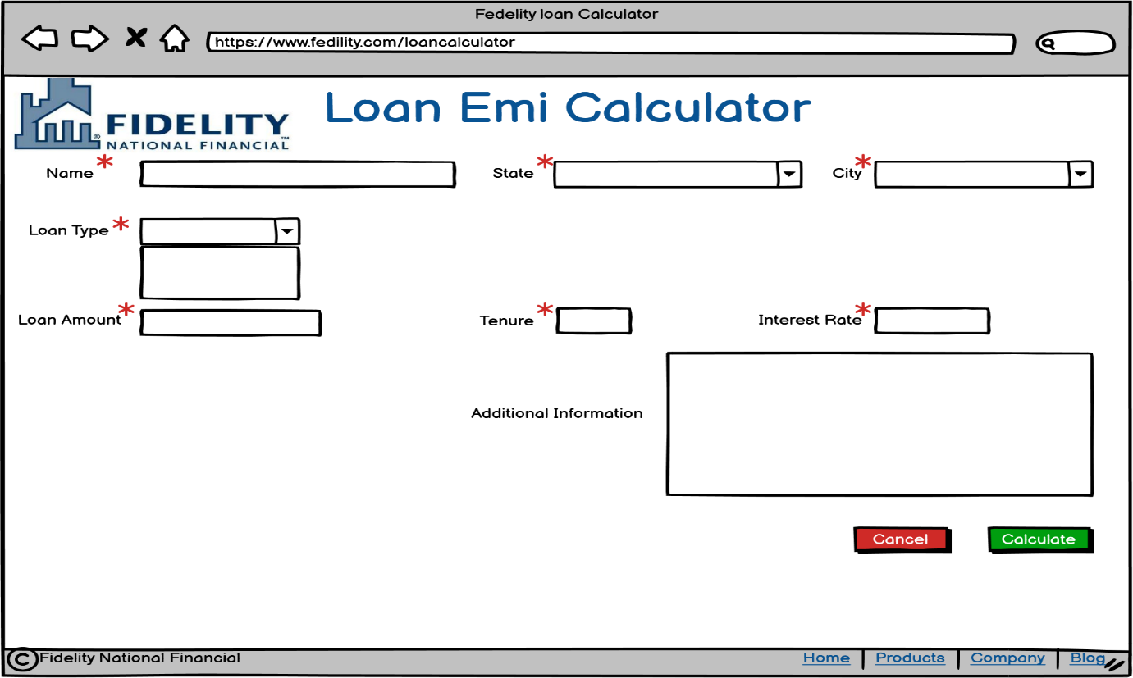
Loan Calculator page

Screen with entered details:
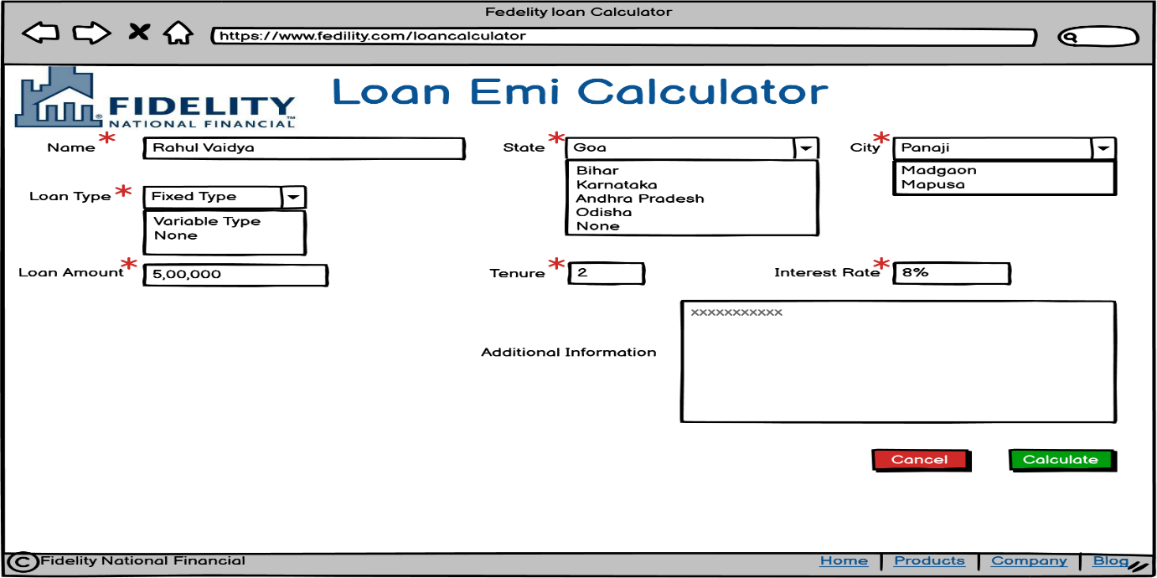

Screen with calculation:
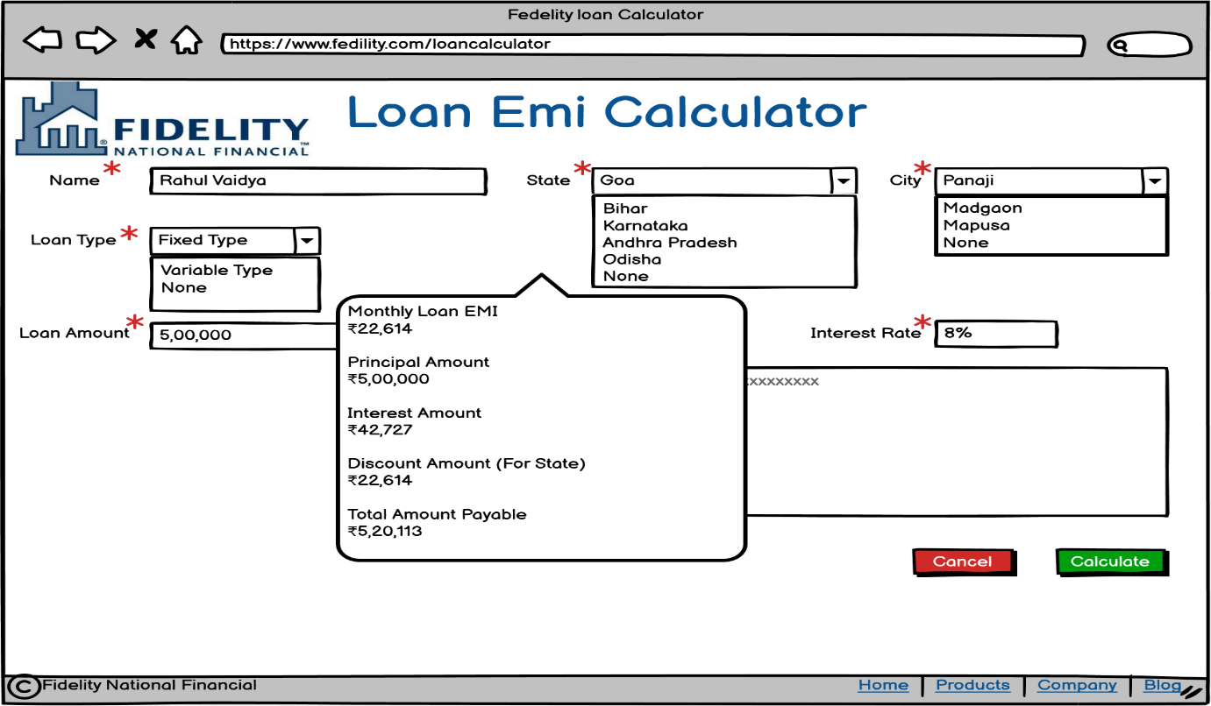

Screen without city selected:
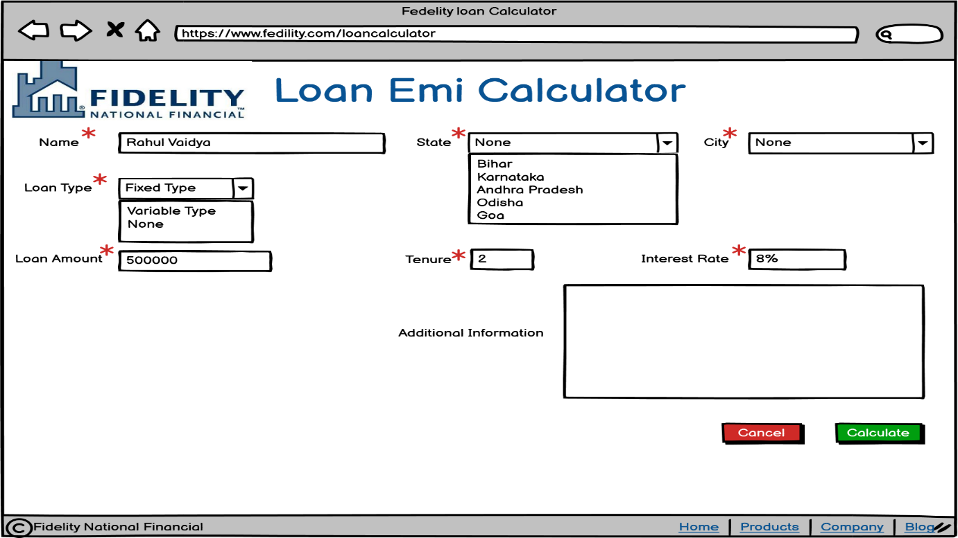
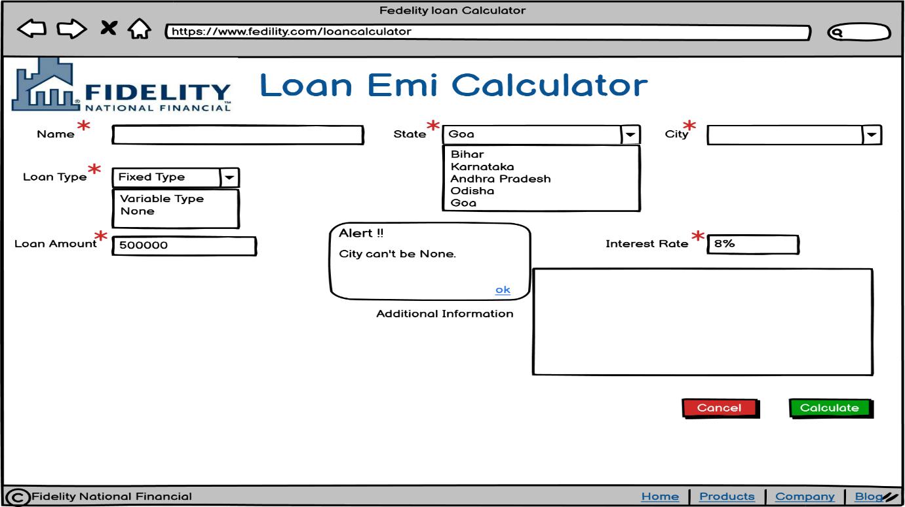

Screen without Loan Type selected:
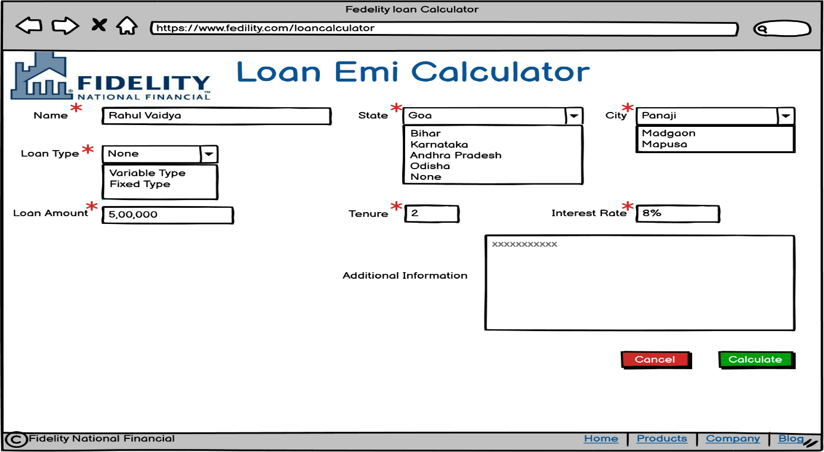
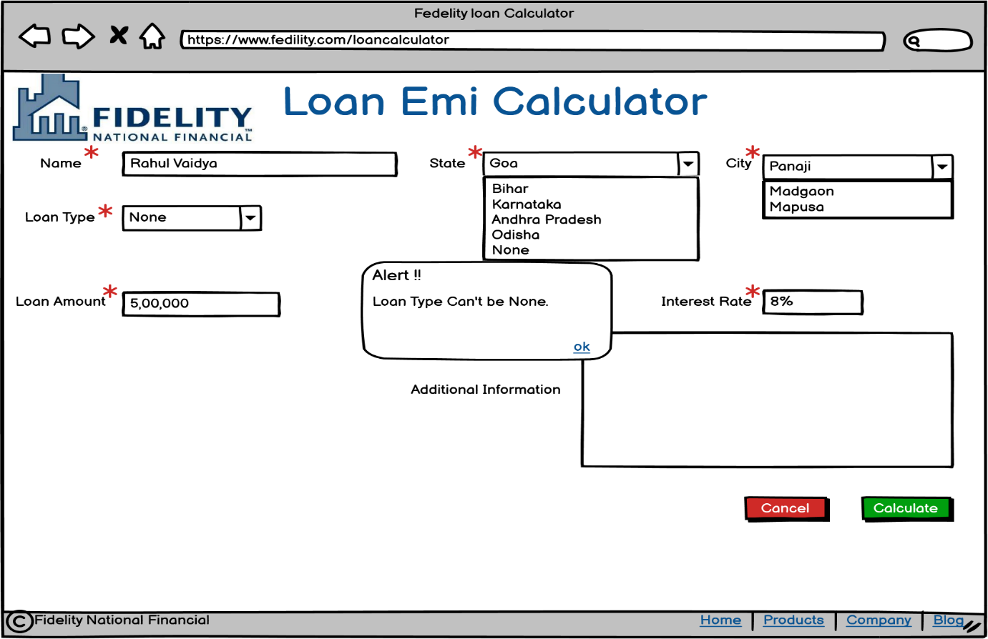

2. OUT OF SCOPE (FEATURES/MODULES/SCREENS/USE CASES)
The following features and functionalities are explicitly excluded from the current phase of the Loan EMI Calculator Application:
User Management
The application will not include any user authentication, registration, or login capabilities in this phase. Users will be able to access the calculator directly without creating accounts, providing credentials, or managing passwords. There will be no role-based access control to differentiate between different types of users such as administrators, loan officers, or customers. User profile management, password recovery mechanisms, and session management features are not part of the current scope. The application assumes open access for all users without any security layers for user identification or authorization.
Data Storage and Retrieval
The application will not store any customer data, loan details, or calculation results in a database or persistent storage system. Each calculation will be performed in real-time without saving the inputs or outputs for future reference. Users will not be able to retrieve previously performed calculations or access historical data from past sessions. There will be no audit trail or logging mechanism to track who performed calculations, when they were performed, or what values were entered. All data will exist only during the active session and will be lost once the user closes the application or refreshes the page.
Multi-Screen Workflows
The application scope is limited to a single-screen interface and does not include multi-step processes or navigation between different pages. There will be no wizard-based flows that guide users through sequential steps for loan application or calculation. Features such as a dedicated results page, a separate input page, or multiple tabs for different calculation scenarios are not included. The entire user experience will be contained within one screen, with the result popup being the only additional interface element.
Advanced Calculations
The application will not support complex loan scenarios beyond basic EMI calculation. Features such as partial payment options, prepayment scenarios, or early loan closure calculations are excluded from this phase. The system will not generate detailed amortization schedules showing month-by-month breakdowns of principal and interest payments. Comparison tools that allow users to evaluate multiple loan options side-by-side or calculate the impact of varying interest rates are not part of the scope. Additional charges such as processing fees, administrative costs, or penalty calculations will not be incorporated into the calculation logic.
Integration Capabilities
The application will function as a standalone tool without any integration with FNF's existing systems or external applications. There will be no connectivity to Customer Relationship Management (CRM) systems, loan origination platforms, or customer databases. The application will not fetch real-time interest rates from external sources or synchronize data with other FNF applications. API development for third-party integrations or web services that allow external systems to consume calculation functionality is not included. All data must be manually entered by users, and the application will not pre-populate information from other systems.
Reporting and Export
The application will not provide any reporting capabilities, export features, or document generation functionality. Users will not be able to download calculation results as PDF files, export data to Excel spreadsheets, or print calculation summaries. Email delivery of results, automated report generation, or scheduled reporting features are excluded from the scope. The calculation results will only be viewable on-screen through the result popup, and users will need to manually note or transcribe the information if they require it for external use.
Additional States or Regions
The state-specific discount policy is limited to Karnataka and Goa only in this phase. Promotional discounts or special benefits for other Indian states or international locations are not included. The application will not support multi-currency calculations for loans in currencies other than the default currency. Geographic expansion to include additional regions, countries, or currency options will require separate project approval and will be considered for future phases based on business requirements.
Administrative Functions
The application will not include any backend administrative interface or configuration management tools. There will be no admin panel for managing master data such as the list of states, cities, or loan types. System administrators will not be able to configure interest rates, modify discount policies, or update business rules through the application interface. Any changes to dropdown values, calculation formulas, or discount logic will require code-level changes and redeployment. User activity monitoring, system health dashboards, and administrative reporting tools are not part of the current scope.
Notifications and Alerts
The application will not send any automated communications to users or customers. Email notifications containing calculation results, SMS alerts for loan information, or push notifications for system updates are excluded from this phase. There will be no reminder functionality, follow-up communications, or scheduled notifications based on user activity. All communication regarding calculation results will be limited to the on-screen display within the result popup, and users will be responsible for capturing and sharing this information through their own channels if needed.
Mobile and Accessibility Features
The development of native mobile applications for iOS or Android platforms is not included in the current scope. The application will be web-based and may or may not be optimized for mobile browser viewing depending on technical specifications. Offline calculation capability that allows users to perform calculations without internet connectivity is excluded. Specific accessibility compliance features to meet WCAG (Web Content Accessibility Guidelines) standards, such as screen reader support, keyboard navigation enhancements, or high-contrast mode, are not explicitly part of this phase unless mandated by technical requirements.
3.1 ACTOR/USER PROFILE SPECIFICATION
Primary Actors
Customers:
- Access the Loan EMI Calculator application through a web-based user interface.
- Enter personal information including name for identification purposes.
- Select geographic location by choosing State and City from dropdown menus.
- Choose the type of loan product from available loan type options.
- Input loan parameters including loan amount, interest rate, and tenure (loan duration).
- Provide additional information through free-flow text box when specific loan types are selected.
- Submit the loan calculation request by clicking the "OK" button.
- View calculated results including EMI amount, total interest, and total payable amount.
- Cancel the calculation process at any time using the "Cancel" button.
- Understand loan financial implications before applying for actual loan products.
- Compare different loan scenarios by modifying input parameters.
Financial Advisors/Bank Representatives:
- Utilize the calculator to demonstrate loan options to potential customers.
- Help customers understand the impact of different interest rates and tenures.
- Provide quick EMI calculations during customer consultation sessions.
- Explain the difference between fixed and variable rate loans using the calculator.
- Leverage state-specific benefits (Karnataka and Goa EMI discount) in customer discussions.
3.2 USECASE DIAGRAM
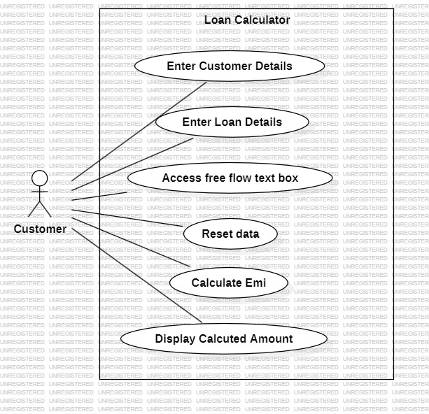

3.3 BUSINESS RULES
BR1: Data Entry and Validation Rules
BR1.1: Mandatory Fields
- All input fields (Name, State, City, Loan Type, Loan Amount, Interest Rate, Tenure) must be filled before submission
- System shall display appropriate error messages for any missing mandatory fields
- OK button functionality shall be dependent on completion of all mandatory fields
BR1.2: Free-Flow Text Box Enablement
- Free-flow text box shall remain disabled/read-only by default
- Free-flow text box shall be enabled ONLY when:
  - City dropdown has a value selected OTHER THAN "None"
  - AND Loan Type dropdown has a value selected OTHER THAN "None"
- If user selects "None" from either City or Loan Type dropdown, free-flow text box shall be immediately disabled
- Any text entered in free-flow text box shall be cleared when the field becomes disabled
BR1.3: Numeric Field Validation
- Loan Amount: Must be a positive numeric value greater than zero
- Interest Rate: Must be a positive numeric value, typically between 0.01% and 50%
- Tenure: Must be a positive integer value representing months or years (to be specified)
BR1.4: Dropdown Dependencies
- City dropdown options shall be filtered/populated based on the State selected
- When State selection changes, City dropdown shall reset to default value
BR2: Loan Calculation Rules
BR2.1: Fixed Rate Loan Calculation
- When Loan Type selected is "Fixed Rate", system shall use fixed rate EMI formula:
  - EMI = [P x R x (1+R)^N] / [(1+R)^N-1]
  - Where: P = Loan Amount, R = Monthly Interest Rate (Annual Rate/12/100), N = Tenure in months
- Interest rate remains constant throughout the loan tenure
- Total Interest = (EMI x N) - P
- Total Amount Payable = EMI x N
BR2.2: Variable Rate Loan Calculation
- When Loan Type selected is "Variable Rate", system shall use variable rate EMI calculation method
- Variable rate calculation method shall account for potential interest rate fluctuations
- Specific calculation formula to be defined based on variable rate methodology used by the organization
- Total Interest and Total Amount Payable shall be calculated considering variable rate scenario
BR2.3: State-Specific Discount Rules
- If selected State is "Karnataka" OR "Goa", system shall apply one EMI discount
- One EMI Discount means: Total Amount Payable = (EMI x N) - EMI
- Discount shall be applied after standard EMI calculation
- Discount shall be clearly indicated in the results display
- States other than Karnataka and Goa shall not receive any discount
BR3: User Action Rules
BR3.1: OK Button Behavior
- OK button shall trigger form validation
- If validation passes, system shall perform EMI calculation based on selected loan type
- System shall apply state-specific discounts if applicable
- Calculation results shall be displayed in a popup window/modal
- Popup shall display: EMI Amount, Total Interest, Total Amount Payable with Interest
BR3.2: Cancel Button Behavior
- Cancel button shall allow user to exit the calculation process
- System shall either clear all entered data (reset form) or close the application window
- No calculation shall be performed when Cancel is clicked
- User shall be able to cancel at any point before or after calculation
BR3.3: Results Display Rules
- Results shall be displayed in a popup/modal window
- Popup shall remain visible until user closes it
- Results shall be formatted with appropriate currency symbols and decimal places
- If state-specific discount applied, this shall be clearly mentioned in the results
BR4: System Behavior Rules
BR4.1: Field Initialization
- All input fields shall be empty/default on initial load
- Dropdowns shall show placeholder text like "Select State", "Select City", "Select Loan Type"
- Free-flow text box shall be disabled on initial load
BR4.2: Error Handling
- System shall display user-friendly error messages for validation failures.
- Error messages shall clearly indicate which field has an issue and what action is required.
- System shall prevent calculation if any business rule is violated.
BR4.3: Data Precision
- EMI amount shall be calculated and displayed with 2 decimal places.
- Interest rate calculations shall maintain precision throughout computation.
- Total interest and total amount payable shall be displayed with 2 decimal places.
FUNCTIONAL REQUIREMENTS
3.1 ACTOR/USER PROFILE SPECIFICATION
Primary Actors
Loan Applicants/Customers:
- Access the Loan EMI Calculator application through a web-based user interface
- Enter personal information including name for identification purposes
- Select geographic location by choosing State and City from dropdown menus
- Choose the type of loan product from available loan type options
- Input loan parameters including loan amount, interest rate, and tenure (loan duration)
- Provide additional information through free-flow text box when specific loan types are selected
- Submit the loan calculation request by clicking the "OK" button
- View calculated results including EMI amount, total interest, and total payable amount
- Cancel the calculation process at any time using the "Cancel" button
- Understand loan financial implications before applying for actual loan products
- Compare different loan scenarios by modifying input parameters
Financial Advisors/Bank Representatives:
- Utilize the calculator to demonstrate loan options to potential customers
- Help customers understand the impact of different interest rates and tenures
- Provide quick EMI calculations during customer consultation sessions
- Explain the difference between fixed and variable rate loans using the calculator
- Leverage state-specific benefits (Karnataka and Goa EMI discount) in customer discussions
Secondary Actors
System Administrator:
- Maintain and update the loan calculation logic and formulas
- Manage dropdown options for States, Cities, and Loan Types
- Configure state-specific benefits and discount rules (e.g., Karnataka and Goa EMI discount)
- Monitor application performance and user activity
- Ensure data validation rules are properly enforced
- Update interest rate calculation methods for fixed and variable loan types
- Manage system access and user permissions if authentication is implemented in future phases
Compliance Officer:
- Ensure calculation formulas comply with banking regulations and standards
- Verify that state-specific benefits are applied correctly and fairly
- Review interest rate calculation methods for regulatory compliance
- Monitor that the application provides accurate financial information to users
- Ensure proper disclaimers are displayed regarding calculation estimates

3.3 BUSINESS RULES
BR1: Data Entry and Validation Rules
BR1.1: Mandatory Fields
- All input fields (Name, State, City, Loan Type, Loan Amount, Interest Rate, Tenure) must be filled before submission
- System shall display appropriate error messages for any missing mandatory fields
- OK button functionality shall be dependent on completion of all mandatory fields
BR1.2: Free-Flow Text Box Enablement
- Free-flow text box shall remain disabled/read-only by default
- Free-flow text box shall be enabled ONLY when:
  - City dropdown has a value selected OTHER THAN "None"
  - AND Loan Type dropdown has a value selected OTHER THAN "None"
- If user selects "None" from either City or Loan Type dropdown, free-flow text box shall be immediately disabled
- Any text entered in free-flow text box shall be cleared when the field becomes disabled
BR1.3: Numeric Field Validation
- Loan Amount: Must be a positive numeric value greater than zero
- Interest Rate: Must be a positive numeric value, typically between 0.01% and 50%
- Tenure: Must be a positive integer value representing months or years (to be specified)
BR1.4: Dropdown Dependencies
- City dropdown options shall be filtered/populated based on the State selected
- When State selection changes, City dropdown shall reset to default value
BR2: Loan Calculation Rules
BR2.1: Fixed Rate Loan Calculation
- When Loan Type selected is "Fixed Rate", system shall use fixed rate EMI formula:
  - EMI = [P x R x (1+R)^N] / [(1+R)^N-1]
  - Where: P = Loan Amount, R = Monthly Interest Rate (Annual Rate/12/100), N = Tenure in months
- Interest rate remains constant throughout the loan tenure
- Total Interest = (EMI x N) - P
- Total Amount Payable = EMI x N
BR2.2: Variable Rate Loan Calculation
- When Loan Type selected is "Variable Rate", system shall use variable rate EMI calculation method
- Variable rate calculation method shall account for potential interest rate fluctuations
- Specific calculation formula to be defined based on variable rate methodology used by the organization
- Total Interest and Total Amount Payable shall be calculated considering variable rate scenario
BR2.3: State-Specific Discount Rules
- If selected State is "Karnataka" OR "Goa", system shall apply one EMI discount
- One EMI Discount means: Total Amount Payable = (EMI x N) - EMI
- Discount shall be applied after standard EMI calculation
- Discount shall be clearly indicated in the results display
- States other than Karnataka and Goa shall not receive any discount
BR3: User Action Rules
BR3.1: OK Button Behavior
- OK button shall trigger form validation
- If validation passes, system shall perform EMI calculation based on selected loan type
- System shall apply state-specific discounts if applicable
- Calculation results shall be displayed in a popup window/modal
- Popup shall display: EMI Amount, Total Interest, Total Amount Payable with Interest
BR3.2: Cancel Button Behavior
- Cancel button shall allow user to exit the calculation process
- System shall either clear all entered data (reset form) or close the application window
- No calculation shall be performed when Cancel is clicked
- User shall be able to cancel at any point before or after calculation
BR3.3: Results Display Rules
- Results shall be displayed in a popup/modal window
- Popup shall remain visible until user closes it
- Results shall be formatted with appropriate currency symbols and decimal places
- If state-specific discount applied, this shall be clearly mentioned in the results
BR4: System Behavior Rules
BR4.1: Field Initialization
- All input fields shall be empty/default on initial load
- Dropdowns shall show placeholder text like "Select State", "Select City", "Select Loan Type"
- Free-flow text box shall be disabled on initial load
BR4.2: Error Handling
- System shall display user-friendly error messages for validation failures
- Error messages shall clearly indicate which field has an issue and what action is required
- System shall prevent calculation if any business rule is violated
BR4.3: Data Precision
- EMI amount shall be calculated and displayed with 2 decimal places
- Interest rate calculations shall maintain precision throughout computation
- Total interest and total amount payable shall be displayed with 2 decimal places

4. DATA REQUIREMENTS
4.1 DATA VOLUMES
4.1.1 Transaction Data Volume
- Expected Daily Calculations: 500-1,000 loan EMI calculations per day (estimated based on user traffic)
- Peak Load Capacity: System should support up to 2,000 calculations per day during promotional periods
- Concurrent Users: Application should handle 50-100 concurrent users performing calculations simultaneously
- Calculation Response Time: Each calculation should complete within 2-3 seconds
4.1.2 Master Data Volume
- State Master Data: Approximately 28-36 records (Indian states and union territories)
- City Master Data: Approximately 500-1,000 records (major cities mapped to states)
- Loan Type Master Data: 5-10 loan type categories (Home Loan, Personal Loan, Vehicle Loan, Education Loan, etc.)
- Configuration Data: State-specific discount rules (currently 2 states: Karnataka and Goa)
4.1.3 User Input Data Size
- Per Calculation Record: Approximately 0.5-1 KB per calculation
  - Name: Up to 100 characters
  - State: Reference ID (4 bytes)
  - City: Reference ID (4 bytes)
  - Loan Type: Reference ID (4 bytes)
  - Free-flow text: Up to 500 characters
  - Loan Amount: Numeric (8-16 bytes)
  - Interest Rate: Decimal (8 bytes)
  - Tenure: Integer (4 bytes)
  - Timestamp: DateTime (8 bytes)
4.1.4 Storage Growth Projection
- Monthly Growth: Approximately 15,000-30,000 calculation records (15-30 MB)
- Annual Growth: Approximately 180,000-360,000 records (180-360 MB)
- 3-Year Projection: Approximately 0.5-1 GB of calculation history data

4.2 DATA CONVERSION
4.2.1 Master Data Setup
- Initial State and City Data Load: One-time conversion of geographic master data from existing banking systems or government sources
  - Source: Existing customer database or external verified sources
  - Format: CSV/Excel files to be imported into application database
  - Validation: Verify completeness and accuracy of state-city mappings
  - Timeline: To be completed before application go-live
4.2.2 Loan Type Configuration
- Loan Product Catalog: Import existing loan product types from core banking system
  - Source: Product management system or loan origination system
  - Mapping: Map existing loan products to standardized loan type categories
  - Interest Rate Templates: Convert standard interest rate ranges for each loan type
  - Timeline: To be completed during system configuration phase
4.2.3 Interest Rate Calculation Methods
- Fixed Rate Formula: Standard banking EMI formula (already industry-standard, no conversion needed)
- Variable Rate Formula: Convert existing variable rate calculation methodology from legacy systems
  - Document current variable rate calculation approach
  - Implement equivalent logic in new application
  - Validate results against legacy system calculations
4.2.4 Historical Data Migration
- Phase 1 Implementation: No historical data migration required as this is a new calculator application
- Future Phases: If user session history or saved calculations are implemented:
  - Define data migration strategy from temporary/session storage to permanent storage
  - Establish user account linking mechanism if authentication is added
4.2.5 Data Format Conversions
- Numeric Conversions:
  - Loan Amount: Support input in various formats (with/without commas, currency symbols)
  - Interest Rate: Support both percentage (e.g., 8.5%) and decimal (e.g., 0.085) formats
  - Tenure: Support both months and years input with automatic conversion
- Text Conversions:
  - Name field: Support Unicode characters for multilingual names
  - Free-flow text: Support special characters and multi-line text input

4.3 DATA RETENTION AND ARCHIVING
4.3.1 Active Data Retention
- Calculation History: Retain calculation records in active database for 12 months
- User Session Data: Retain session-specific data for 24 hours or until session expires
- Master Data: State, City, and Loan Type data retained indefinitely in active database
- Configuration Data: Discount rules and interest rate configurations retained indefinitely
4.3.2 Archiving Strategy
- Archival Trigger: Calculation records older than 12 months to be archived
- Archival Frequency: Monthly archival process on the 1st day of each month
- Archive Storage: Archived data to be moved to separate archive database or data warehouse
- Archive Format: Compressed data files in standard format (CSV/Parquet) for long-term storage
- Archive Accessibility: Archived data accessible for reporting and audit purposes with 24-48 hour retrieval time
4.3.3 Data Purging Policy
- Purge Timeline: Data older than 7 years to be permanently deleted (unless regulatory requirements mandate longer retention)
- Purge Approval: Data purging to be approved by Compliance and Data Governance teams
- Purge Documentation: Maintain audit log of all purged data with timestamps and approver details
- Exceptions: Regulatory or legal hold data to be excluded from purging process
4.3.4 Backup and Recovery
- Backup Frequency: Daily incremental backups, weekly full backups
- Backup Retention: Daily backups retained for 30 days, weekly backups retained for 12 months
- Recovery Point Objective (RPO): Maximum 24 hours of data loss acceptable
- Recovery Time Objective (RTO): System restoration within 4 hours
- Backup Testing: Quarterly backup restoration testing to ensure data integrity
4.3.5 Audit Trail Retention
- System Access Logs: Retain for 3 years minimum
- Calculation Audit Logs: Retain for 5 years for regulatory compliance
- Configuration Change Logs: Retain indefinitely for system maintenance history
- Error Logs: Retain for 1 year in active system, archive for additional 2 years

4.4 PRIVACY IMPLICATIONS
4.4.1 Personal Data Collection
- Personally Identifiable Information (PII):
  - Name: Collected for identification purposes only
  - Geographic Location (State/City): Collected for calculation purposes and discount eligibility
  - Free-flow text: May contain additional personal information provided voluntarily by user
- Sensitive Data: Loan amount and financial parameters are considered sensitive financial information
- Data Classification: All user input data classified as "Confidential - Personal Financial Information"
4.4.2 Data Privacy Compliance
- Regulatory Compliance:
  - Comply with applicable data protection regulations (Information Technology Act, 2000, and Digital Personal Data Protection Act, 2023 in India)
  - Implement privacy by design principles in application architecture
  - Ensure data minimization - collect only necessary information for loan calculation
- User Consent:
  - Display privacy notice and terms of use before data collection
  - Obtain explicit user consent for data collection and processing
  - Provide clear information on how data will be used
- Right to Access and Deletion:
  - Provide mechanism for users to request access to their calculation history (if stored)
  - Implement data deletion capability upon user request
  - Respond to data subject requests within regulatory timelines (typically 30 days)
4.4.3 Data Security Measures
- Data Encryption:
  - Encrypt data in transit using TLS 1.2 or higher (HTTPS)
  - Encrypt sensitive data at rest in database
  - Implement field-level encryption for PII (Name) and financial data
- Access Controls:
  - Implement role-based access control (RBAC) for system administrators
  - Restrict access to user data on need-to-know basis
  - Maintain access logs for all data access activities
- Anonymization:
  - Anonymize or pseudonymize data used for analytics and reporting
  - Remove direct identifiers (Name) from data used for statistical analysis
  - Implement data masking for non-production environments (development, testing)
4.4.4 Data Sharing and Third-Party Access
- Internal Use Only: User calculation data to be used only within the organization
- No Third-Party Sharing: User data shall not be shared with third parties without explicit consent
- Service Providers: If cloud services or third-party vendors are used:
  - Ensure data processing agreements (DPA) are in place
  - Verify vendor compliance with data protection standards
  - Conduct vendor security assessments
- Analytics: Aggregated, anonymized data may be used for business analytics without personal identifiers
4.4.5 Data Breach Response
- Incident Response Plan: Establish data breach response procedure
- Breach Notification: Notify affected users within 72 hours of breach discovery (as per regulatory requirements)
- Regulatory Reporting: Report data breaches to relevant authorities as required by law
- Breach Documentation: Maintain detailed records of security incidents and remediation actions
4.4.6 User Privacy Rights
- Transparency: Provide clear privacy policy explaining data collection, use, and retention
- User Rights:
  - Right to know what data is collected
  - Right to access their calculation history
  - Right to correct inaccurate information
  - Right to delete their data (Right to be Forgotten)
  - Right to data portability (export their data)
- Cookie/Session Management:
  - Inform users about session cookies or local storage usage
  - Provide option to clear session data
  - Respect browser "Do Not Track" settings where applicable
4.4.7 Children's Privacy
- Age Restriction: Application not intended for users under 18 years of age
- Parental Consent: If minors access the application, obtain parental consent before data collection
- Special Protections: Implement additional safeguards if children's data is processed
4.4.8 Cross-Border Data Transfer
- Data Residency: User data to be stored within the country of operation (India) unless explicitly required otherwise
- International Transfers: If data transferred internationally, ensure adequate protection mechanisms:
  - Standard Contractual Clauses (SCCs)
  - Adequacy decisions by data protection authorities
  - User consent for cross-border transfers
- Local Data Storage: Prioritize local data centers to minimize cross-border data flow
5. NON-FUNCTIONAL REQUIREMENTS
5.1 SECURITY REQUIREMENTS
5.1.1 Authentication
AU-001: User Authentication (Future Phase)
- Phase 1 (Current): No authentication required as the calculator is a public utility tool accessible to all users without login
- Phase 2 (Future Enhancement): If user profile and calculation history features are implemented:
  - Support multiple authentication methods: Username/Password, Email OTP, Mobile OTP
  - Implement Multi-Factor Authentication (MFA) for sensitive operations
  - Password complexity requirements: Minimum 8 characters with uppercase, lowercase, numbers, and special characters
  - Account lockout after 5 consecutive failed login attempts
  - Session timeout after 15 minutes of inactivity
AU-002: Session Management
- Generate unique session tokens for each user session
- Session tokens must be cryptographically secure (minimum 128-bit entropy)
- Implement secure session storage with HTTPOnly and Secure flags
- Automatic session expiration after 30 minutes of inactivity
- Logout functionality to terminate session immediately
- Prevent session fixation and session hijacking attacks
AU-003: API Authentication (System-to-System)
- If backend APIs are exposed, implement API key-based authentication
- Use OAuth 2.0 or JWT (JSON Web Tokens) for API authorization
- API keys must be rotated every 90 days
- Rate limiting on API endpoints to prevent abuse
AU-004: Password Management
- Passwords must be hashed using industry-standard algorithms (bcrypt, Argon2, or PBKDF2)
- Never store passwords in plain text or reversible encryption
- Implement password reset functionality with time-limited tokens (valid for 1 hour)
- Password history: Users cannot reuse last 5 passwords
- Force password change every 90 days for administrator accounts
5.1.2 Authorization and Access Controls
AZ-001: Role-Based Access Control (RBAC)
- Define distinct user roles with specific permissions:
  - Public User: Access to calculator interface only, no administrative functions
  - Financial Advisor: Same as public user plus ability to save/retrieve calculation history (future phase)
  - System Administrator: Full access to configuration, master data management, and system settings
  - Compliance Officer: Read-only access to audit logs, calculation records, and configuration settings
  - IT Support: Access to system logs, performance monitoring, and technical configuration
AZ-002: Function-Level Access Control
- Public calculator functions accessible to all users without restrictions
- Master data management (State, City, Loan Type) restricted to System Administrators only
- Configuration changes (interest rates, discount rules) require System Administrator role
- Audit log viewing restricted to Compliance Officers and System Administrators
- User data access limited by role and need-to-know principle
AZ-003: Data Access Controls
- Users can only view their own calculation history (if authentication implemented)
- System Administrators cannot view individual user calculations without audit trail
- Database access restricted to application service account only
- Direct database access for administrators only with proper authorization and logging
- Principle of Least Privilege (PoLP) applied to all system accounts and roles
AZ-004: Administrative Controls
- All administrative actions must be logged with timestamp, user ID, and action details
- Critical configuration changes require dual approval (maker-checker principle)
- Administrative access restricted to specific IP addresses or VPN connections
- Regular access reviews conducted quarterly to verify appropriate permissions
- Immediate revocation of access upon role change or employee termination
AZ-005: Application Security
- Implement input validation and sanitization to prevent injection attacks (SQL injection, XSS, CSRF)
- Use parameterized queries for all database operations
- Implement CSRF tokens for all state-changing operations
- Content Security Policy (CSP) headers to prevent XSS attacks
- Regular security vulnerability scanning and penetration testing (annually)
AZ-006: Data Encryption
- All data transmission encrypted using TLS 1.2 or higher (HTTPS mandatory)
- Sensitive data encrypted at rest using AES-256 encryption
- Encryption keys managed through secure key management system
- Database connections encrypted using SSL/TLS
- Secure key rotation policy implemented (annual rotation minimum)
AZ-007: Security Monitoring and Logging
- Log all authentication attempts (successful and failed)
- Log all authorization failures and access denials
- Log all configuration changes with before/after values
- Security logs retained for minimum 3 years
- Real-time alerting for suspicious activities (multiple failed logins, unauthorized access attempts)
- Security Information and Event Management (SIEM) integration for centralized monitoring

5.2 AVAILABILITY REQUIREMENTS
AV-001: System Uptime
- Target Availability: 99.5% uptime during business hours (9 AM - 6 PM local time)
- Extended Availability: 99% uptime for 24x7 operation
- Scheduled Maintenance Window: Maximum 4 hours per month during non-business hours (preferably weekends)
- Advance Notification: Users notified 48 hours before planned maintenance
- Maximum Downtime: Unplanned downtime should not exceed 4 hours per month
AV-002: Disaster Recovery
- Recovery Time Objective (RTO): System restored within 4 hours of failure
- Recovery Point Objective (RPO): Maximum 24 hours of data loss acceptable
- Disaster Recovery Site: Maintain active-passive or active-active failover setup
- DR Testing: Conduct disaster recovery drills twice annually
- Backup Verification: Weekly verification of backup integrity and restoration capability
AV-003: Business Continuity
- Documented business continuity plan maintained and updated annually
- Alternate processing site available in case of primary site failure
- Critical system components should have redundancy (database, application servers, network)
- Automated failover mechanisms for critical components
- Communication plan for notifying stakeholders during outages
AV-004: Service Level Agreements (SLA)
- Critical Severity Issues: Resolution within 4 hours
- High Severity Issues: Resolution within 8 business hours
- Medium Severity Issues: Resolution within 24 business hours
- Low Severity Issues: Resolution within 5 business days
- Monthly SLA compliance reports generated and reviewed
AV-005: Monitoring and Alerting
- 24x7 system monitoring for availability and performance
- Automated health checks every 5 minutes
- Alert notifications to IT support team within 2 minutes of issue detection
- Monitoring dashboard accessible to IT operations team
- Proactive monitoring for resource utilization (CPU, memory, disk space)
AV-006: High Availability Architecture
- Load balancing across multiple application servers
- Database replication with automatic failover
- Redundant network connections and infrastructure
- No single point of failure in critical system components
- Geographic distribution of infrastructure for regional resilience

5.3 USABILITY REQUIREMENTS
US-001: User Interface Design
- Clean, intuitive, and clutter-free interface design
- Consistent design language across all screens and components
- Responsive design supporting desktop, tablet, and mobile devices (minimum 320px width)
- Material Design or Bootstrap-based UI framework for modern look and feel
- Color contrast ratio meeting WCAG 2.1 Level AA standards (minimum 4.5:1 for normal text)
US-002: Ease of Use
- New users should be able to perform calculation without training or documentation
- Maximum 3 clicks/steps required to complete a loan calculation
- Clear and descriptive field labels with tooltips where necessary
- Logical tab order for keyboard navigation
- Auto-focus on first input field when page loads
US-003: Form Input Experience
- Dropdown menus with search/filter capability for State and City selection
- Auto-population of City dropdown based on State selection
- Clear indication of mandatory fields (asterisk or visual indicator)
- Input field formatting assistance (e.g., automatic comma insertion for loan amount)
- Real-time validation with inline error messages displayed immediately
US-004: Error Handling and Messaging
- Clear, concise, and user-friendly error messages
- Error messages explain what went wrong and how to fix it
- Avoid technical jargon in user-facing error messages
- Field-level error highlighting with descriptive messages
- Success confirmation messages for completed calculations
US-005: Accessibility Requirements
- WCAG 2.1 Level AA compliance for accessibility
- Keyboard navigation support for all interactive elements
- Screen reader compatibility with proper ARIA labels
- Alt text for all images and icons
- Sufficient color contrast for visually impaired users
- Font size minimum 14px, with option to increase to 18px
- Support for browser zoom up to 200% without horizontal scrolling
US-006: Internationalization and Localization
- Support for multiple languages (English, Hindi, and regional languages as Phase 2)
- Date and number formatting based on locale
- Currency display with appropriate symbol (₹ for INR)
- Right-to-left (RTL) language support if applicable
- Cultural considerations in UI design and content
US-007: Response Time and Feedback
- Page load time should not exceed 3 seconds on standard broadband connection
- Calculation results displayed within 2 seconds of clicking OK button
- Loading indicators displayed for operations taking more than 1 second
- Immediate feedback on user actions (button clicks, form submissions)
- Smooth animations and transitions (not exceeding 300ms)
US-008: Help and Guidance
- Contextual help icons (?) next to complex fields
- Tooltip information appearing on hover or click
- Example values or placeholders in input fields
- Clear instructions at the top of the form
- "What is EMI?" or similar educational content accessible from interface

5.4 SYSTEM HELP REQUIREMENTS
SH-001: Inline Help
- Context-sensitive help tooltips for all input fields
- Help icon (?) next to field labels providing detailed explanations
- Tooltips should appear on hover (desktop) and tap (mobile)
- Tooltip content limited to 2-3 sentences for quick understanding
- Examples: "Enter your loan amount in rupees (e.g., 500000 for 5 lakhs)"
SH-002: Help Documentation
- Comprehensive user guide accessible from main interface
- Step-by-step instructions with screenshots for performing calculations
- Explanation of financial terms (EMI, Interest Rate, Tenure, Fixed Rate, Variable Rate)
- FAQs section addressing common user questions
- Help documentation available in PDF format for offline reference
SH-003: Educational Content
- "How EMI is calculated" section with formula explanation
- Comparison of Fixed vs Variable rate loans with examples
- Information about state-specific benefits (Karnataka and Goa discount)
- Tips for choosing appropriate loan tenure and amount
- Glossary of financial terms used in the application
SH-004: Interactive Help
- Guided tour or walkthrough for first-time users (optional overlay)
- Sample calculation with pre-filled values for demonstration
- Interactive tutorial explaining each field and its purpose
- Video tutorial embedded or linked from help section (future phase)
SH-005: Error Resolution Help
- Specific help content linked from error messages
- "Learn more" links in error messages directing to relevant help section
- Common error scenarios documented with solutions
- Troubleshooting guide for technical issues
SH-006: Contact Support
- "Help" or "Contact Us" link prominently displayed
- Email address and phone number for customer support
- Expected response time clearly communicated (e.g., "We respond within 24 hours")
- Support hours clearly mentioned
- Feedback form for users to report issues or suggestions
SH-007: Help Content Management
- Help content should be easily updatable without code changes
- Version control for help documentation
- Regular review and update of help content (quarterly)
- User feedback mechanism for help content effectiveness
- Search functionality within help documentation

5.5 PERFORMANCE REQUIREMENTS
PF-001: Response Time Requirements
- Page Load Time: Initial page load within 3 seconds on 4G connection
- Calculation Time: EMI calculation completed and results displayed within 2 seconds
- Dropdown Population: State/City dropdown options loaded within 1 second
- Form Validation: Real-time validation feedback within 500 milliseconds
- API Response Time: Backend API calls respond within 1.5 seconds (95th percentile)
PF-002: Throughput Requirements
- Support minimum 100 concurrent users performing calculations simultaneously
- Handle 500-1,000 calculations per day during normal operations
- Support peak load of 2,000 calculations per day during promotional periods
- Process 50 transactions per second during peak hours
- No performance degradation during peak usage times
PF-003: Resource Utilization
- CPU Utilization: Average CPU usage should not exceed 60% during normal operations
- Memory Usage: Application memory footprint should not exceed 2 GB per instance
- Database Connections: Efficient connection pooling with maximum 50 concurrent connections
- Network Bandwidth: Minimize data transfer; page size should not exceed 500 KB
- Client-side Performance: Minimal JavaScript execution time (< 100ms for calculations)
PF-004: Browser Performance
- Compatible with latest 2 versions of Chrome, Firefox, Safari, and Edge
- Smooth performance on devices with minimum 2GB RAM
- Responsive interface with smooth animations (60 fps)
- Efficient DOM manipulation with minimal reflows and repaints
- Optimized asset loading (images, CSS, JavaScript compressed and minified)
PF-005: Database Performance
- Database query execution time should not exceed 500 milliseconds
- Efficient indexing on frequently queried fields (State, City, Loan Type)
- Query optimization for master data retrieval
- Connection pooling to reduce connection overhead
- Database cache utilization for frequently accessed master data
PF-006: Network Performance
- Minimize HTTP requests through asset bundling and concatenation
- Enable gzip compression for text-based resources
- Implement browser caching with appropriate cache headers
- Use CDN for static assets (CSS, JavaScript, images)
- Lazy loading for non-critical resources
PF-007: Performance Monitoring
- Real-time performance monitoring dashboard
- Track key performance indicators (KPIs): response time, throughput, error rate
- Automated alerts when performance metrics exceed thresholds
- Monthly performance reports and trend analysis
- Performance testing before each release (load testing, stress testing)
PF-008: Performance Optimization
- Code profiling to identify and optimize bottlenecks
- Database query optimization based on execution plans
- Caching strategy for master data (State, City, Loan Type)
- Asynchronous processing for non-critical operations
- Regular performance tuning and optimization cycles

5.6 SCALABILITY REQUIREMENTS
5.6.1 Customer Scalability
CS-001: User Growth Projection
- Year 1: Support 50,000-100,000 unique users per month
- Year 2: Scale to 200,000-300,000 unique users per month
- Year 3: Scale to 500,000-750,000 unique users per month
- Long-term: Architecture should support 1 million+ unique users per month
- Organic growth accommodation without major infrastructure changes
CS-002: Geographic Scalability
- Initially support users from all states in India
- Expand to support international users in Phase 2 (if applicable)
- Multi-region deployment for reduced latency (North, South, East, West zones)
- Support for regional language preferences and localization
- Geographic load distribution based on user location
CS-003: Concurrent User Scalability
- Phase 1: Support 100 concurrent users
- Phase 2: Scale to 500 concurrent users
- Phase 3: Scale to 1,000+ concurrent users
- Auto-scaling based on real-time user demand
- Load testing validated for 150% of expected concurrent user capacity
CS-004: Transaction Volume Scalability
- Support linear scalability in calculation transaction volume
- Handle 10x increase in daily calculations without architectural changes
- Peak load handling during promotional campaigns or events
- No performance degradation with increasing transaction volume
- Horizontal scaling capability to add capacity during peak periods
CS-005: User Data Scalability
- If user profiles and calculation history implemented:
  - Support storage of calculation history for millions of users
  - Efficient data retrieval regardless of user base size
  - Data partitioning strategy for large-scale data management
  - Archive older calculations to maintain performance
5.6.2 Application Scalability
AS-001: Horizontal Scalability
- Stateless application architecture enabling easy horizontal scaling
- Support deployment across multiple application server instances
- Load balancer distribution of traffic across application servers
- Auto-scaling groups to add/remove instances based on demand
- Containerized deployment (Docker/Kubernetes) for easy scaling
AS-002: Vertical Scalability
- Application should efficiently utilize increased server resources (CPU, RAM)
- Support vertical scaling by upgrading server specifications
- No hard-coded limits on resource utilization
- Efficient memory management to leverage additional RAM
- Multi-threaded processing to utilize multiple CPU cores
AS-003: Database Scalability
- Database architecture supporting read replicas for load distribution
- Master-slave replication for read-heavy operations
- Database sharding strategy for horizontal data distribution (future phase)
- Support for NoSQL databases if relational database becomes bottleneck
- Database connection pooling with dynamic pool sizing
AS-004: Microservices Architecture (Future Phase)
- Modular architecture allowing independent scaling of components:
  - Calculation Service: Scale independently based on calculation demand
  - Master Data Service: Handle high-volume lookups for State/City/Loan Type
  - User Service: Manage user authentication and profiles (future phase)
  - Reporting Service: Generate reports without impacting calculator performance
- API Gateway for routing and load balancing across microservices
- Service mesh for inter-service communication and resilience
AS-005: Caching Strategy
- Implement multi-level caching for improved scalability:
  - Browser Cache: Cache static assets (CSS, JavaScript, images)
  - Application Cache: Cache master data (State, City, Loan Type) in memory
  - Distributed Cache: Redis or Memcached for shared caching across instances
  - Database Query Cache: Cache frequently executed queries
- Cache invalidation strategy for data updates
- Cache warming for master data on application startup
AS-006: Content Delivery Network (CDN)
- Use CDN for serving static assets globally
- Edge caching for reduced latency and improved scalability
- Geographic distribution of content for faster access
- CDN integration for image optimization and compression
- Offload static content delivery from application servers
AS-007: Asynchronous Processing
- Non-critical operations processed asynchronously using message queues
- Background jobs for data archival, reporting, and analytics
- Event-driven architecture for loosely coupled components
- Message queue (RabbitMQ, Kafka) for handling high-volume events
- Retry mechanisms for failed asynchronous operations
AS-008: API Rate Limiting and Throttling
- Implement rate limiting to prevent abuse and ensure fair usage
- Throttling mechanisms to protect backend systems during overload
- Graceful degradation under extreme load conditions
- Priority queuing for critical operations
- Circuit breaker pattern to prevent cascade failures
AS-009: Scalability Testing
- Regular load testing to validate scalability targets
- Stress testing to identify breaking points
- Soak testing to identify memory leaks and resource exhaustion
- Spike testing to validate auto-scaling effectiveness
- Performance benchmarking before and after each major release
AS-010: Cloud-Native Scalability
- Leverage cloud provider auto-scaling capabilities (AWS Auto Scaling, Azure Scale Sets)
- Serverless computing for specific components (AWS Lambda, Azure Functions)
- Cloud-native services for managed scalability (RDS, DynamoDB, CosmosDB)
- Infrastructure as Code (IaC) for repeatable environment provisioning
- Multi-availability zone deployment for high availability and scalability

APPROVAL
This Business Requirements Document (BRD) for the Loan EMI Calculator Application has been prepared for review and formal approval by the authorized stakeholders of Fidelity National Financial. The document represents the agreed-upon business requirements, scope, and objectives for the project as understood at the time of publication.
By signing below, stakeholders acknowledge that they have reviewed the contents of this document and approve the requirements as documented. Any changes to the approved requirements after sign-off will be managed through FNF's formal change control process and may impact project timeline, budget, and resource allocation.

Stakeholder Name |  |  | Role/Title | Signature | Date
Stakeholder Name | Role/Title | Signature | Date

